### Experiment Guidebook 2

#### Experimental requirements and objective

1. Be able to code, assemble, and execute a program with Visual C++ and MASM.
2. Know how to link your programs to an external code library.
3. Know how to create conditional and looping structures using assembly language.

#### Experimental environment

1. Hardware environment

The x86 microcomputer CPU more than Pentium, more than 120GB capacity hard drive, more than 1GB of memory.

1. Software environment

Visual Studio 2008 or above version.

#### Experimental contents

1. Write a procedure that takes three arguments: a character and two integers. The character is to be printed. The first integer specifies the number of times that the character is to be printed on a line, and the second integer specifies the number of lines that are to be printed. Write a program that makes use of this procedure.

**Your report needs to include your code and record the input/output of your program in the consoler.**

; AddTwo.asm - adds two 32-bit integers.

; Chapter 3 example

;.386

;.model flat,stdcall

;.stack 4096

;ExitProcess proto,dwExitCode:dword

INCLUDE Irvine32.inc

.data

chara BYTE ?

num1 DWORD ?

num2 DWORD ?

.code

main PROC

mov chara, 'A'

mov num1, 5

mov num2, 3

call PrintCharacter

exit

main ENDP

INVOKE ExitProcess,0

PrintCharacter PROC

mov ecx, num2 ; Number of lines

L1:

mov edx, num1 ; Number of characters per line

L2:

call WriteChar

dec edx

jnz L2

call Crlf

dec ecx

jnz L1

mov esp, ebp

pop ebp

ret

PrintCharacter ENDP

END main

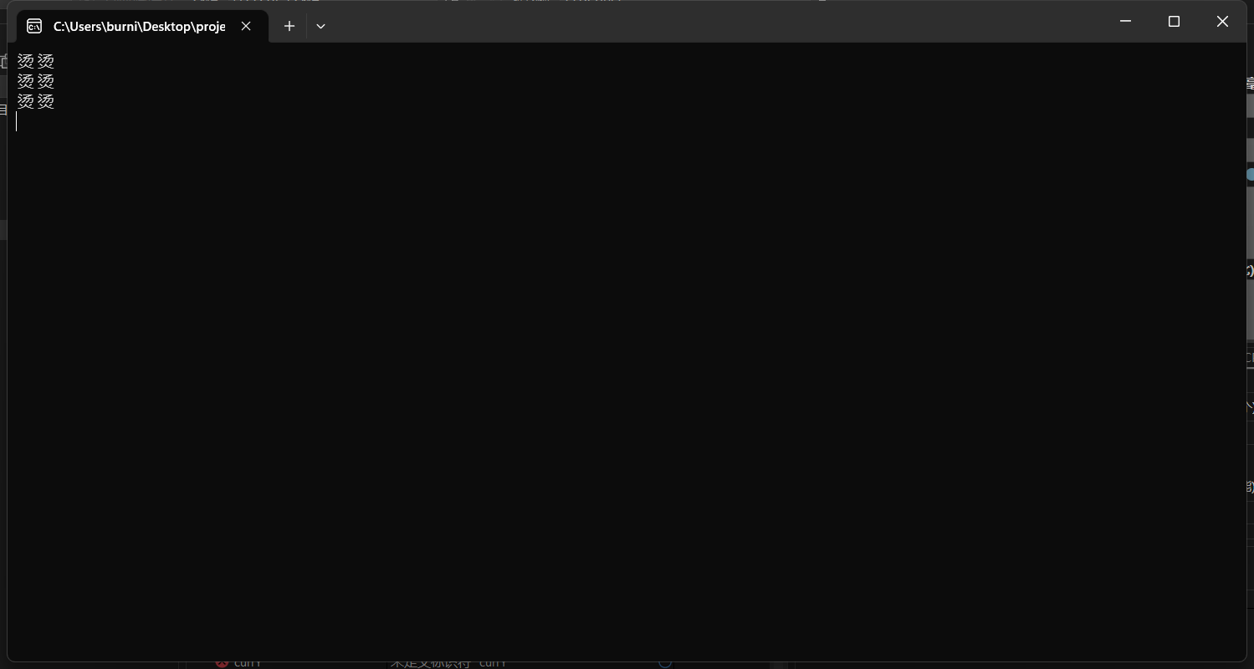

1. Write a procedure that sets each element in an array to the sum of the corresponding elements in two other arrays. (That is, if array 1 has the values 2 , 4 , 5 , and 8, and array 2 has the values 1 , 0 , 4 , and 6, the function assigns array 3 the values 3 , 4 , 9 , and 14.) The procedure should take each address of the three arrays and the array size as arguments. Test the procedure in a simple program.

**Your report needs to include your code and record the input/output of your program in the consoler.**

; AddTwo.asm - adds two 32-bit integers.

; Chapter 3 example

;.386

;.model flat,stdcall

;.stack 4096

;ExitProcess proto,dwExitCode:dword

INCLUDE Irvine32.inc

.data

array1 DWORD 2,4,5,8

array2 DWORD 1,0,4,6

array3 DWORD ?

.code

main PROC

mov edi,OFFSET array1

mov esi,OFFSET array2

mov ebx,OFFSET array3

mov eax,0

mov ecx,LENGTHOF array1

L1:

add eax,[edi]

add eax,[esi]

add edi,TYPE array1

add esi,TYPE array2

mov [ebx],eax

add ebx,TYPE array3

loop L1

mov esi,OFFSET array3

mov ecx,4

mov ebx,4

call DumpMem

INVOKE ExitProcess,0

main ENDP

END main

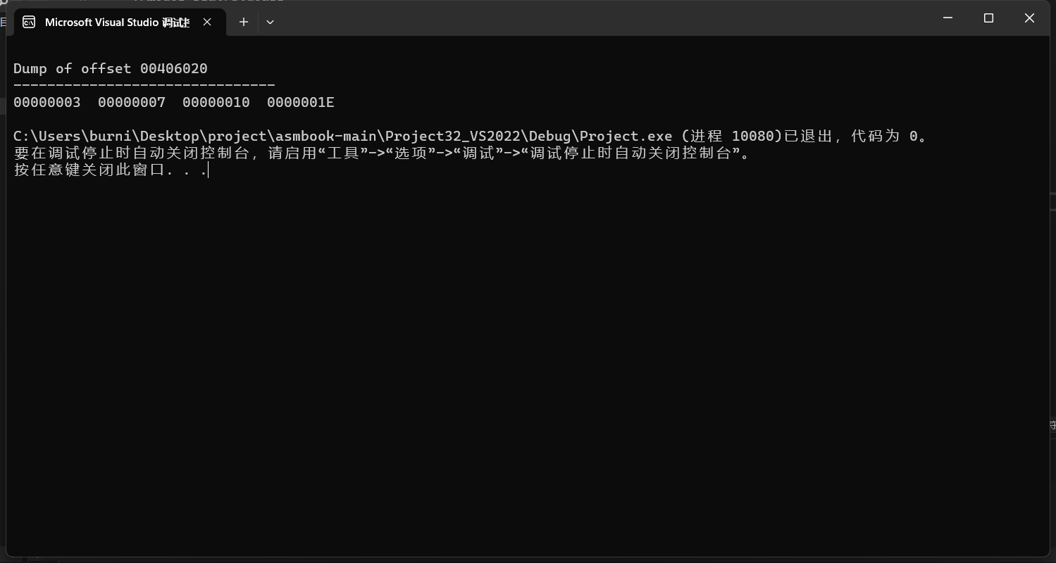

1. Write a program that prompts the user to enter three sets of five integer numbers each. (You may assume the user responds correctly and doesn’t enter non-numeric data.) The program should accomplish all of the following:

a. Store the integers in a 3×5 array.

b. Compute the sum of each set of five values, and display the results.

c. Compute the sum of all the values, and display the results.

d. Determine the largest value of the 15 values, and display the results.

Each major task should be handled by a separate procedure.

**Your report needs to include your code and record the input/output of your program in the consoler.**